A

Project Report

On

**INCOME TAX DEPARTMENT**

Website Design

Submitted to

**SHIVAJI UNIVERSITY, KOLHAPUR**

For the partial fulfillment of the requirement for the award **BACHELOR OF COMPUTER APPLICATION (SEM –V)**

By

# Jeet Nilesh Joshi

**Noman Iftikharali Jamadar**

Under the guidance of

# Dr. A. B. Patil

Through

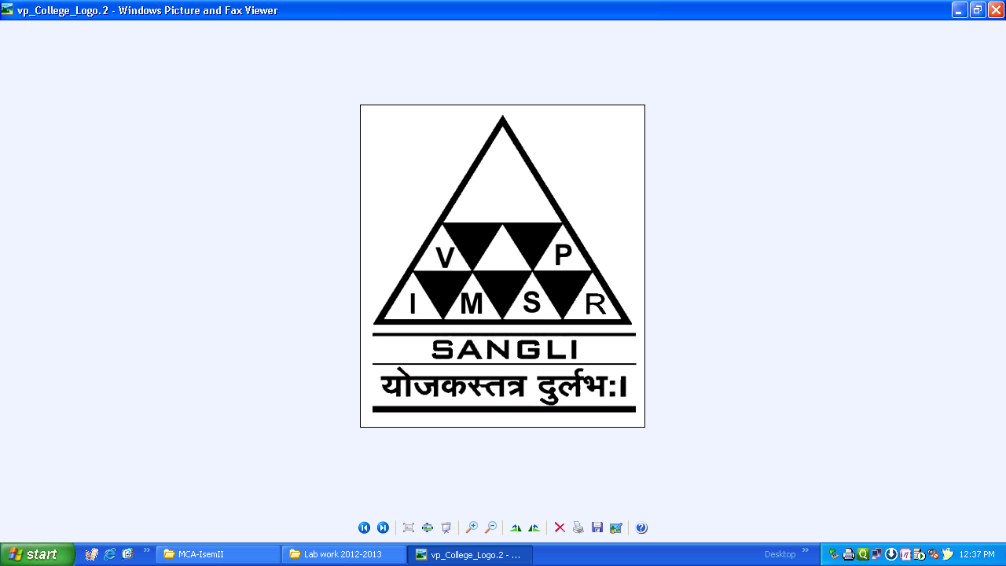

The principal

**V. P. INSTITUTE OF MANAGEMENT STUDIES AND RESEARCH, SANGLI**

**2021-22**

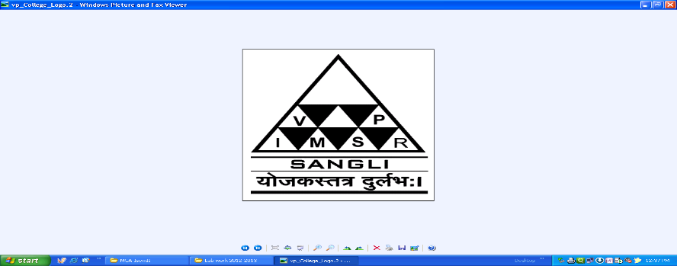**V. P. Institute of Management**

**Studies & Research, Sangli- 416414**

Certificate

**Department of Computer Application**

This is to certify that, the project report entitled **Income Tax Department** is record of project work carried out in this college by **Mr. Jeet Nilesh Joshi and Mr. Noman Iftikharali Jamadar** in partial fulfillment of the award of Bachelor of Computer Application (Sem-V) as laid down by SHIVAJI UNIVERSITY, KOLHAPUR.

This project presents their sincere work carried out under my guidance in the year 2020-21.

Date:

Dr. A. B. Patil Dr. Mrs. V. S. Jadhav

**Guide**  **H.O.D.**

Examiner: 1) 2)

## DECLARATION

To,

The Registrar,

Shivaji University, Kolhapur

Sir,

We undersigned **Mr.** **Jeet Nilesh Joshi, Mr. Noman Iftikharali Jamadar** hereby declare that, the project report entitled **Income Tax Department** submitted by us under the guidance of **Dr. A. B. Patil,** is our original work.

We have not reproduced any information from any report submitted to Shivaji University, Kolhapur this year or any of the previous years.

We understand that any such copying is liable to punish in a way that University Authorities deem fit.

Place: Sangli

Date:

**Acknowledgement**

We acknowledge with gratitude to **Dr. R. A. Shinde** the principal of **V.P. Institute of Management Studies and Research, Sangli** for giving us this wonderful opportunity to work in this institute.

In addition, we would like to thank our faculty **Prof. A. R. Rasal** and **Dr. V. S. Jadhav** Head of Computer Department (V.P.I.M.S.R), for their valuable support.

We have to give gratitude to **Dr. A. B. Patil** our project guide for guiding us throughout the project and for their valuable suggestions which help us a lot in the completion of this project.

Also we like to take opportunity thank our all Computer faculties, administration and library staff for their support throughout the project.

Last but not least we would also thank our friends who have helped us directly and indirectly for successfully completing this project.

**Place:** Sangli.

**Date:**

**Mr. Jeet Nilesh Joshi**

**Mr. Noman Iftikharali Jamadar**

**INDEX**

|  |  |  |
| --- | --- | --- |
| **Sr. No.** | **Contents** | **Page No.** |
| **1** | **Introduction to Project**  1.1] Introduction  1.2] Existing System  1.3] Need and scope of Computer System |  |
| **2** | **Proposed System**  2.1] Objectives  2.2] Requirement Engineering  • Requirement Gathering  • SRS |  |
| **3** | **System Analysis**  3.1] System Diagram  • DFD  • ERD |  |
| **4** | **System Design**  4.1] Database Design  4.2] Input Design  4.3] Output Design |  |
| **5** | **Implementation**  5.1] System Requirement  Hardware  Software  5.2] User Guideline |  |
| **6** | **Conclusion and Suggestions**  7.1] Conclusion  7.2] Limitations  7.3] Suggestion |  |
| **7** | **References:-**   * Books * Journals * Source code (Include Main Logic source code) * Site Map |  |

**1] Introduction to Project**

* 1. **Introduction**

This website is "Income Tax Department"

We have designed a website " Income Tax Department”. We have developed this website to provide a single window access to the income tax related services for taxpayers and other stakeholders.

* 1. **Existing System**

[www.incometaxindia.gov.in](http://www.incometaxindia.gov.in) system has its own official websites. Also, different related websites related is www.incometax.gov.in etc.

* 1. **Need & Scope of Computer system**

A few factors that direct us to develop a new system are given below:

* Faster System
* Accuracy
* Reliability
* Informative Reservations

**2] Proposed system**

**2.1 Objectives**

The main objective of this project through is to:

* To Formulate Progressive Tax Policy
* To Provide Efficient and Effective Administration
* To Promote Voluntary Compliance

**2.2 Requirements**

**2.2.1 Requirement Gathering Tools**

* Organizational Website- [www.incometaxindia.gov.in](http://www.incometaxindia.gov.in)
* Search Engine- [www.google.com](http://www.google.com)
* Encyclopaedia-www.wikipedia.com
* Discuss with end users about their exception, interaction with web designer/Developers.

**2.2.2 Software Requirement Specification (SRS)**

* Detail information about Income Tax Department
* Alternative, webpage & easy access
* Help taxpayers to file their Income Tax returns online
* The website can be accessed by taxpayers at any given time

**3] System Analysis**

**3.1 DFD**

The DFD is also called as bubble chart. It is a simple graphical formalism that can be used to represent a system in terms of input data to the system, various processing carried out on this data, and the output data is generated by this system. The data flow diagram (DFD) is one of the most important modelling tools. It is used to model the system components. These components are the system process, the data used by the process, an external entity that interacts with the system and the information flows in the system shows how the information moves through the system and how it is modified by a series of transformations. It is a graphical technique that depicts information flow and the transformations that are applied as data moves from input to outputted is also known as bubble chart. A DFD may be used to represent a system at any level of abstraction. DFD may be partitioned into levels that represent increasing information flow and functional detail.

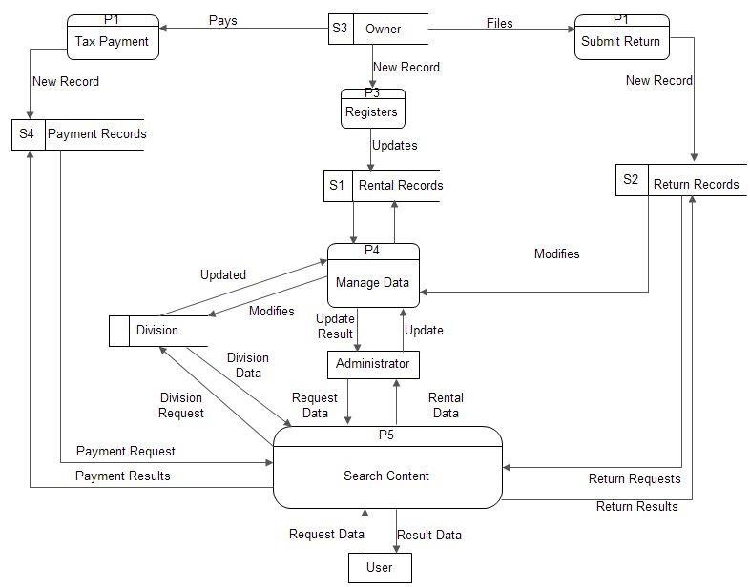

**3.2 ERD**

An entity relationship diagram (ERD) shows the relationships of entity sets stored in a database. An entity in this context is a component of data. In other words, ER diagrams illustrate the logical structure of databases.

At first glance an entity relationship diagram looks very much like a flowchart. It is the specialized symbols, and the meanings of those symbols, that make it unique.

An entity relationship diagram is a means of visualizing how the information a system produces is related. There are five main components of an ERD:

Entities, which are represented by rectangles. An entity is an object or concept about which you want to store information.

Entity

A weak entity is an entity that must defined by a foreign key relationship with another entity as it cannot be uniquely identified by its own attributes alone.

Entity

Actions, which are represented by diamond shapes, show how two entities share information in the database.

Relationship

In some cases, entities can be self-linked. For example, employees can supervise other employees.

Attributes, which are represented by ovals. A key attribute is the unique, distinguishing characteristic of the entity. For example, an employee's social security number might be the employee's key attribute.

A multivalve attribute can have more than one value. For example, an employee entity can have multiple skill values.

A derived attribute is based on another attribute. For example, an employee's monthly salary is based on the employee's annual salary.

Connecting lines, solid lines that connect attributes to show the relationships of entities in the diagram.

Cardinality specifies how many instances of an entity relate to one instance of another entity. Cardinality is also closely linked to cardinality. While cardinality specifies the occurrences of a relationship, Cardinality describes the relationship as either mandatory or optional. In other words, cardinality specifies the maximum number of relationships and Cardinality specifies the absolute minimum number of relationships.

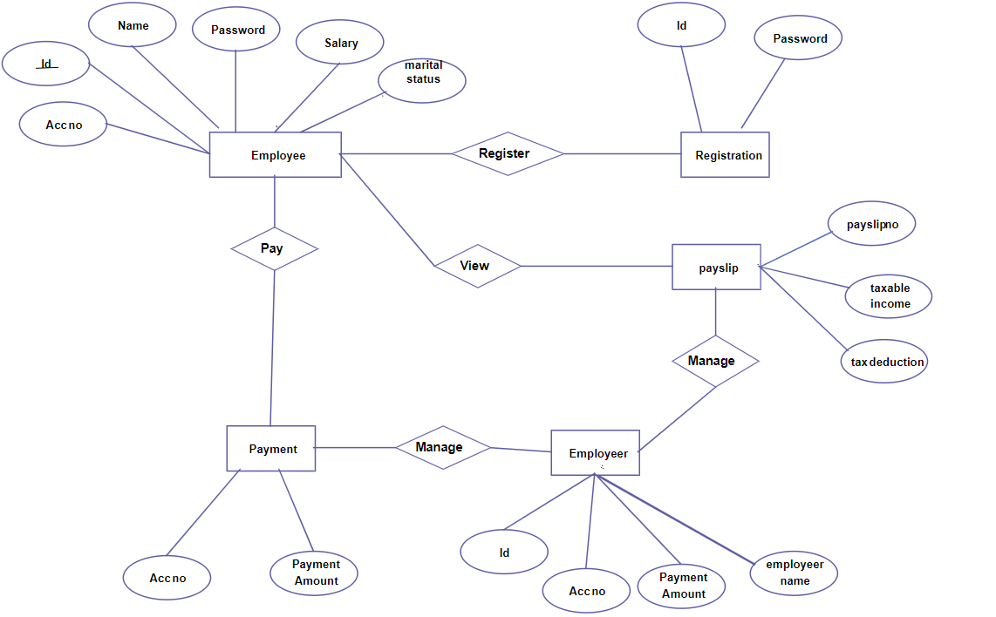

**4]System Design**

**4.1] Database Design**

**Table Name: Client Complaint**

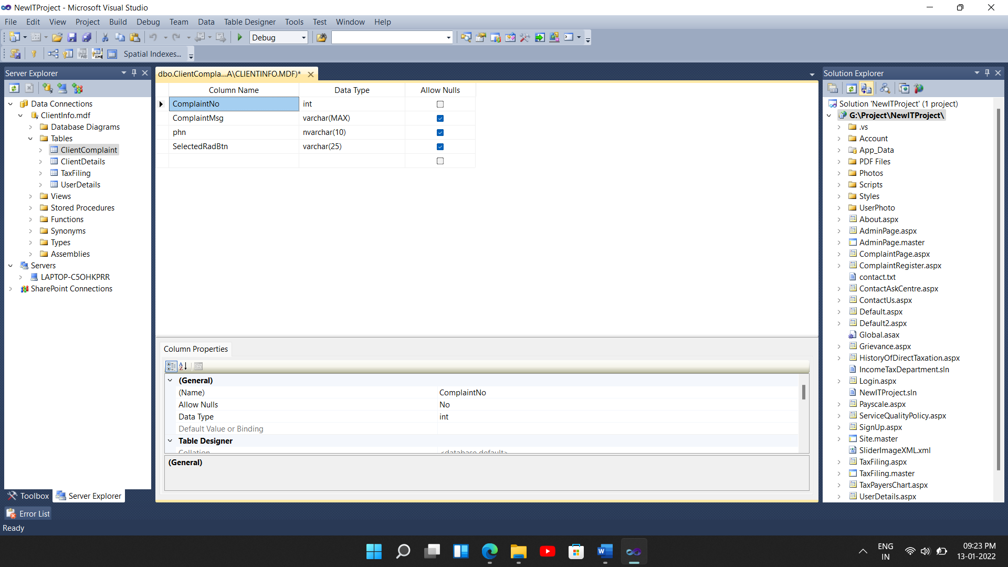

**Table Name: Client Details**

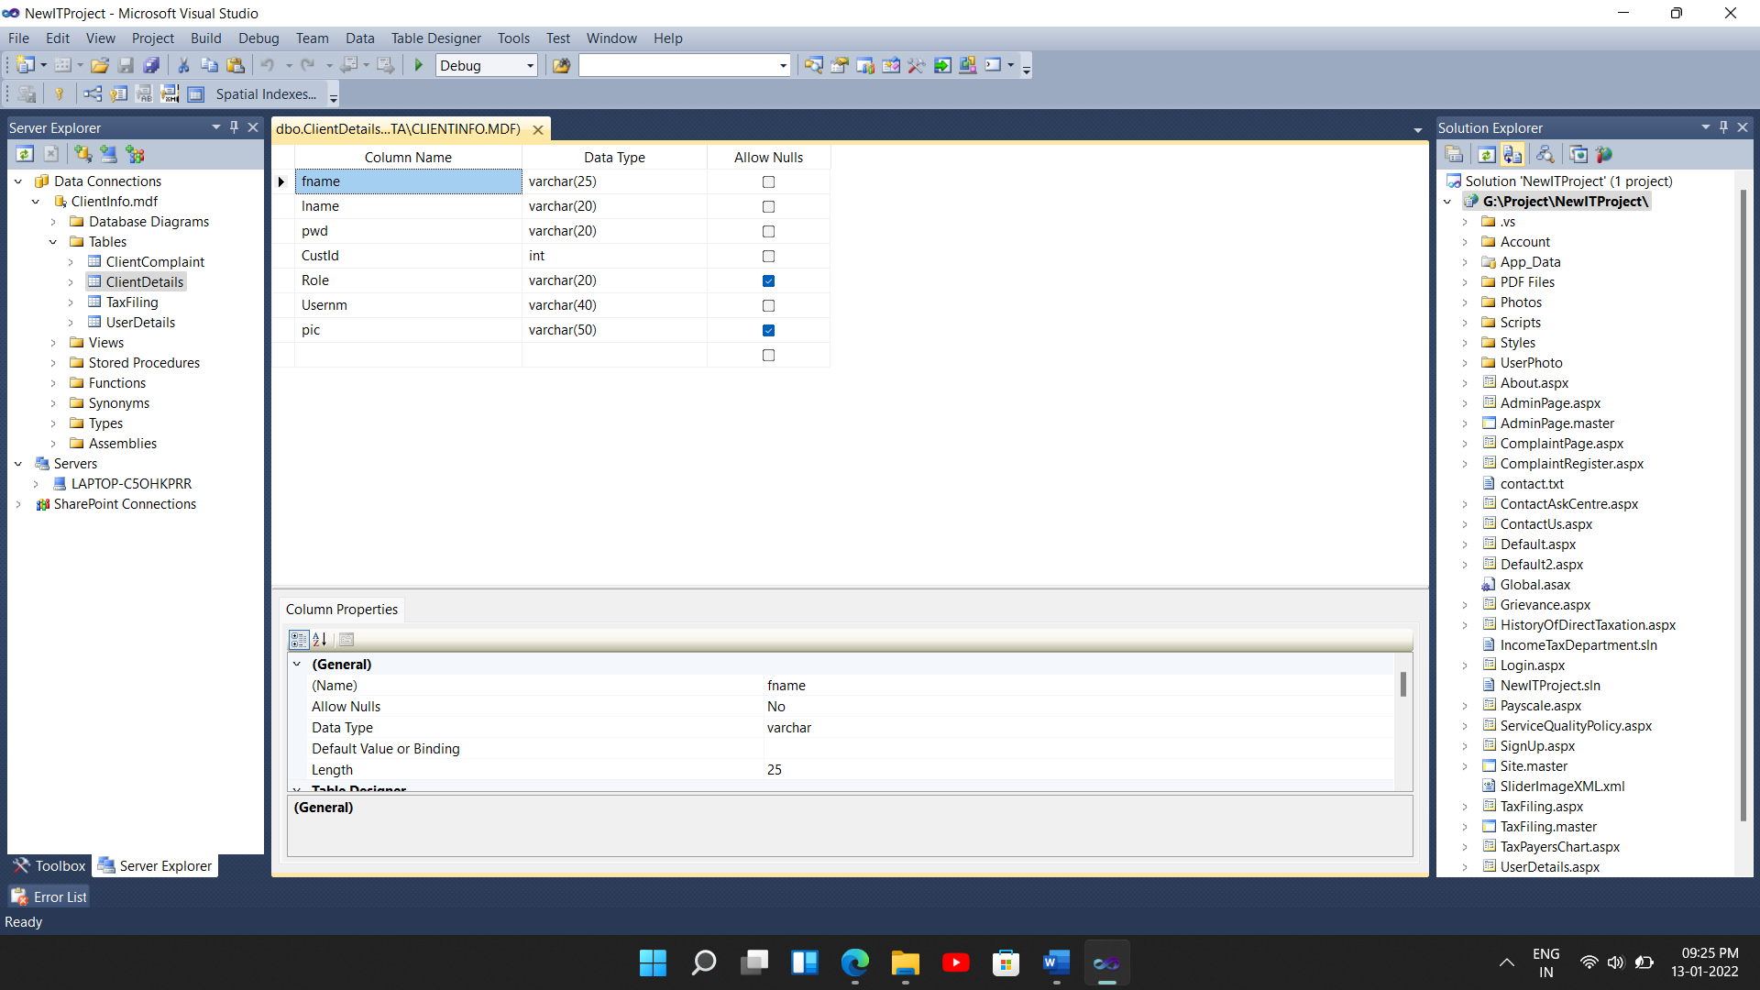

**Table Name: Tax Filing**

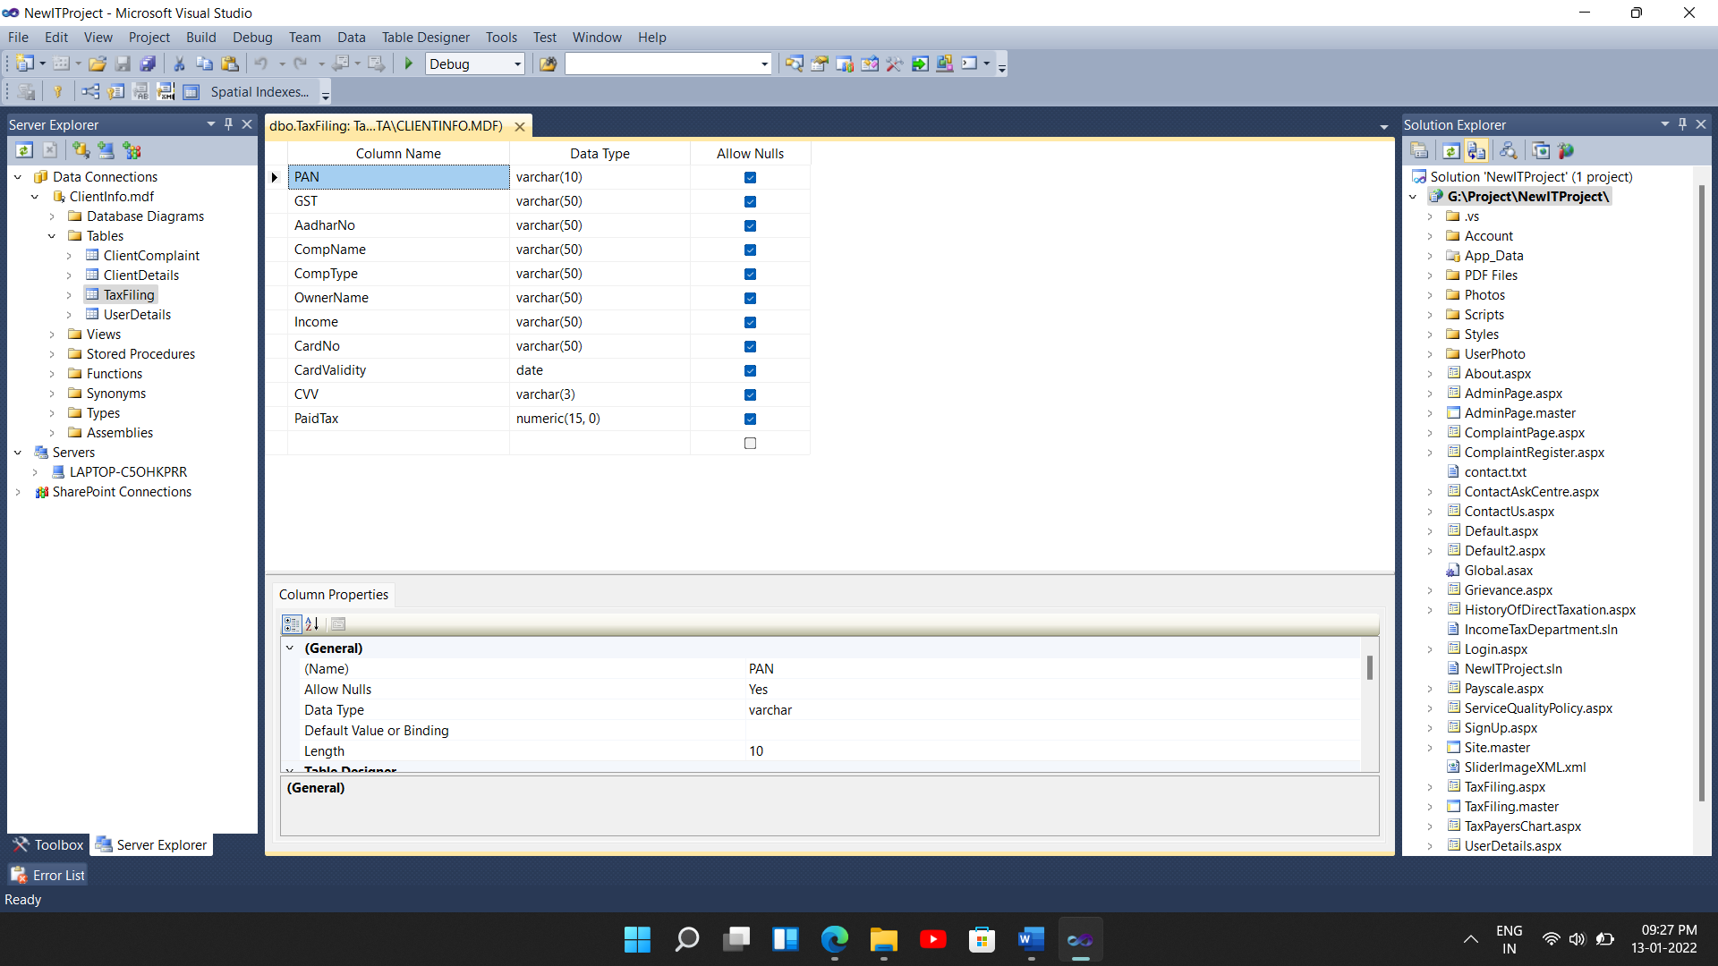

**4.2] Input Design**

**a) Log In Page**

**Name:** Log in

**Description:**

If the User login from this page it redirects to the User account. If the Admin login from this page he’ll redirect towards Admin pages.

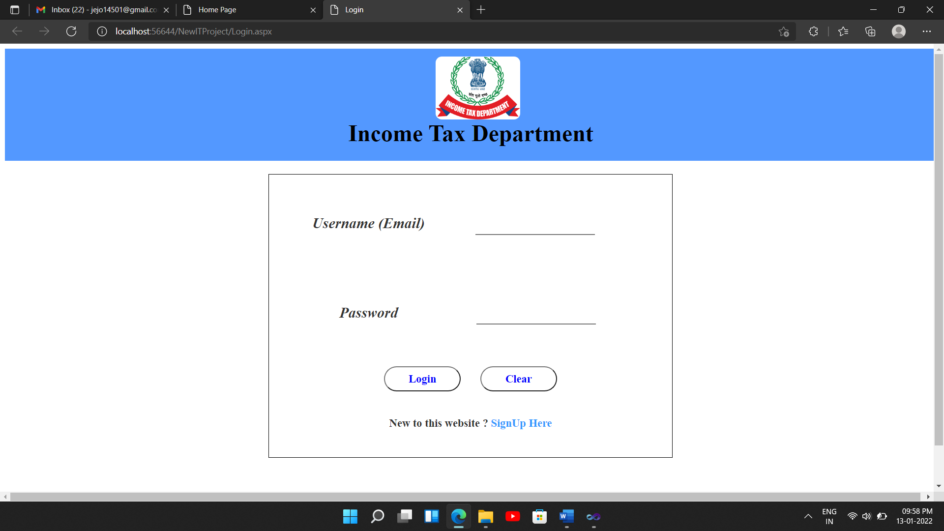

**b) Sign Up Page**

**Name:** Sign Up

**Description:**

If the User wants to create an account, then User have to enter details in this page and from this page it redirects to the Login Page.

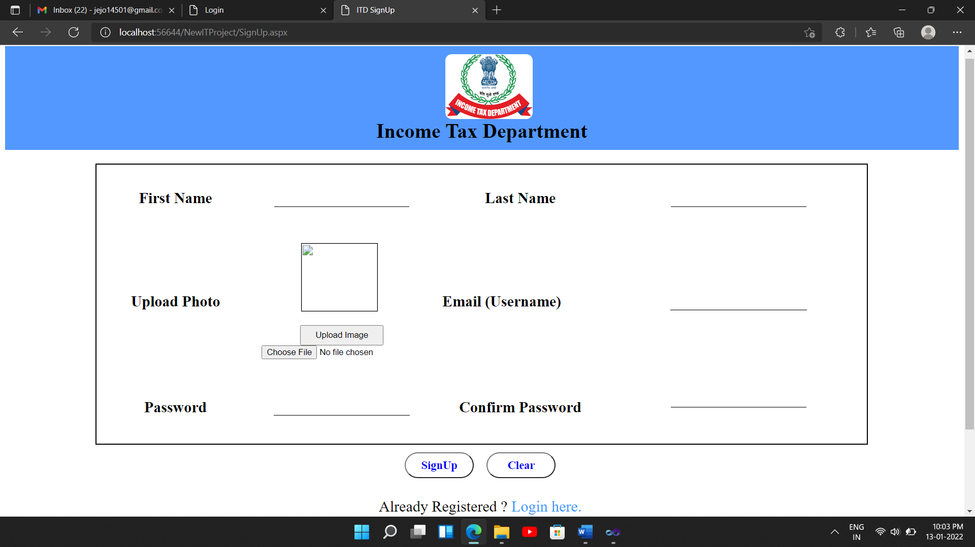

**c) Complaint Register Page**

**Name:** Complaint Register

**Description:**

If the User wants to complaint anything regarding the tax filing or about any other services then he/she can enter the complaint through this page.

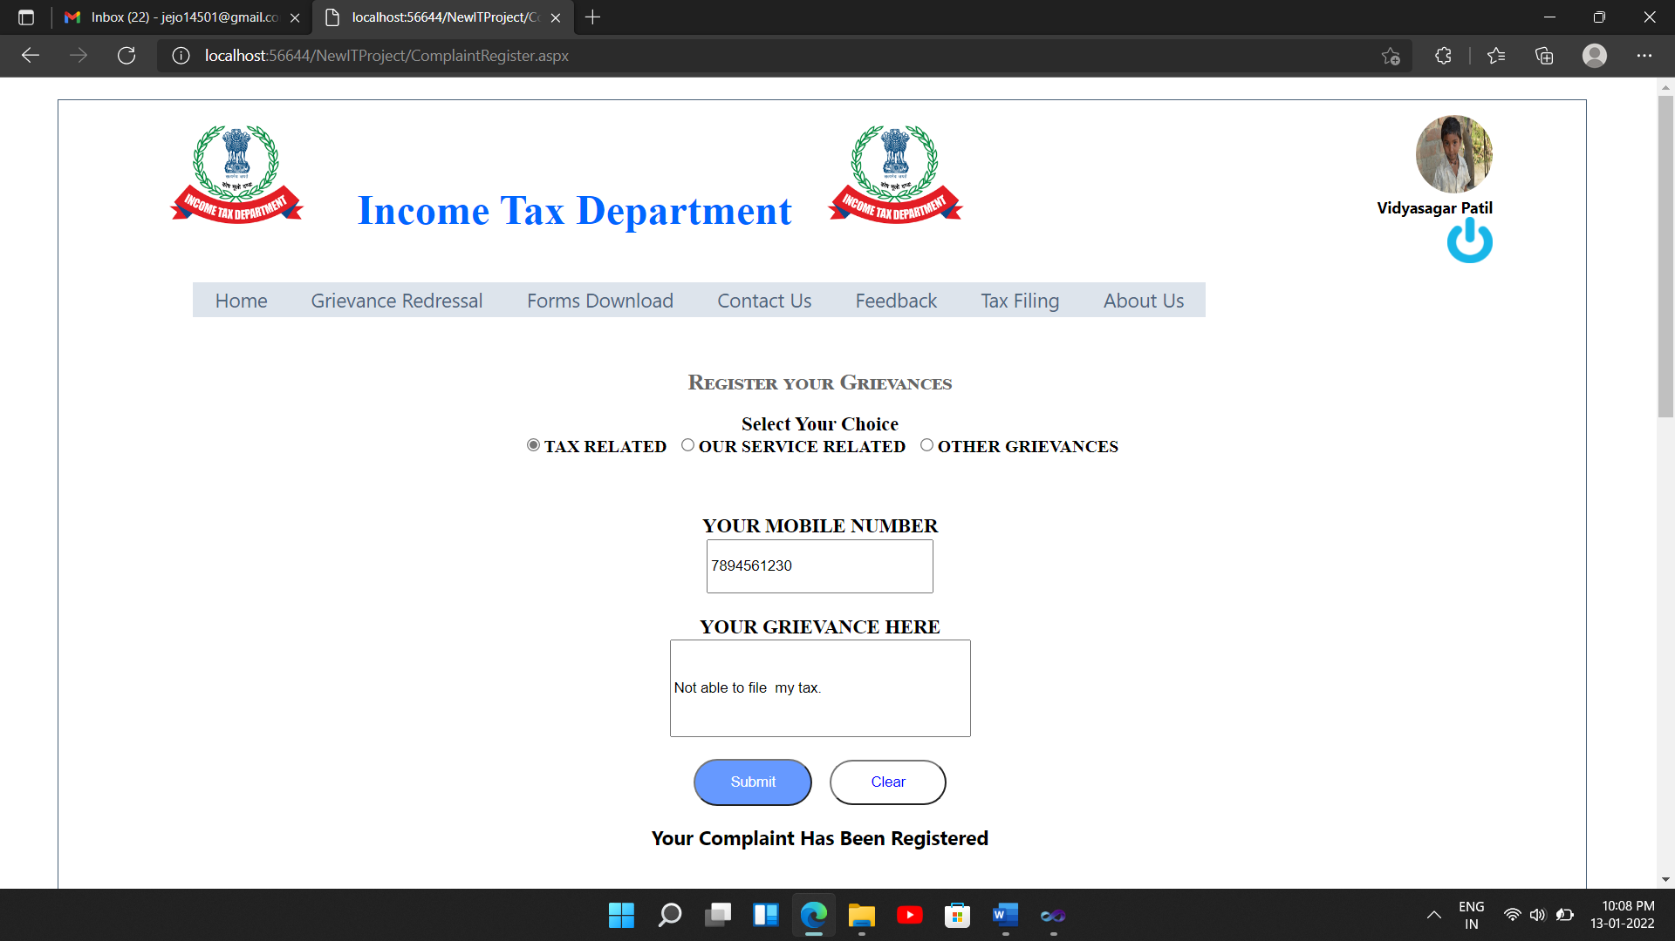

**d) Tax Payer Registration Page**

**Name:** Tax Payer Registration

**Description:**

Any user who is entitled to pay the tax, first have to create the user’s log.

For this the user has to register through this page

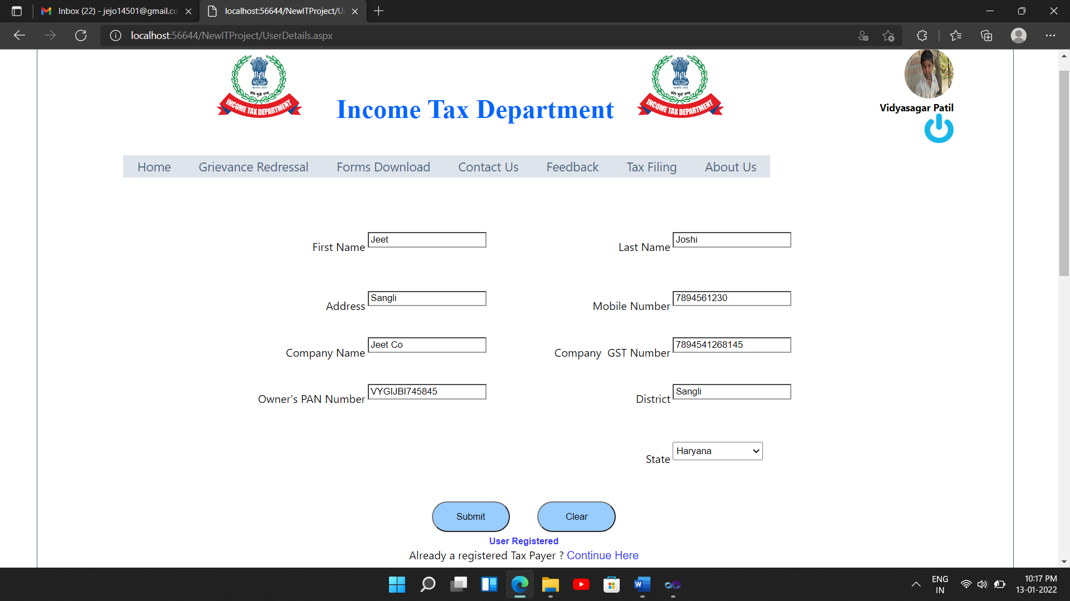

**e) Income Tax Filing Page**

**Name:** Tax Filing

**Description:** This page enables user to pay their income tax through this page.

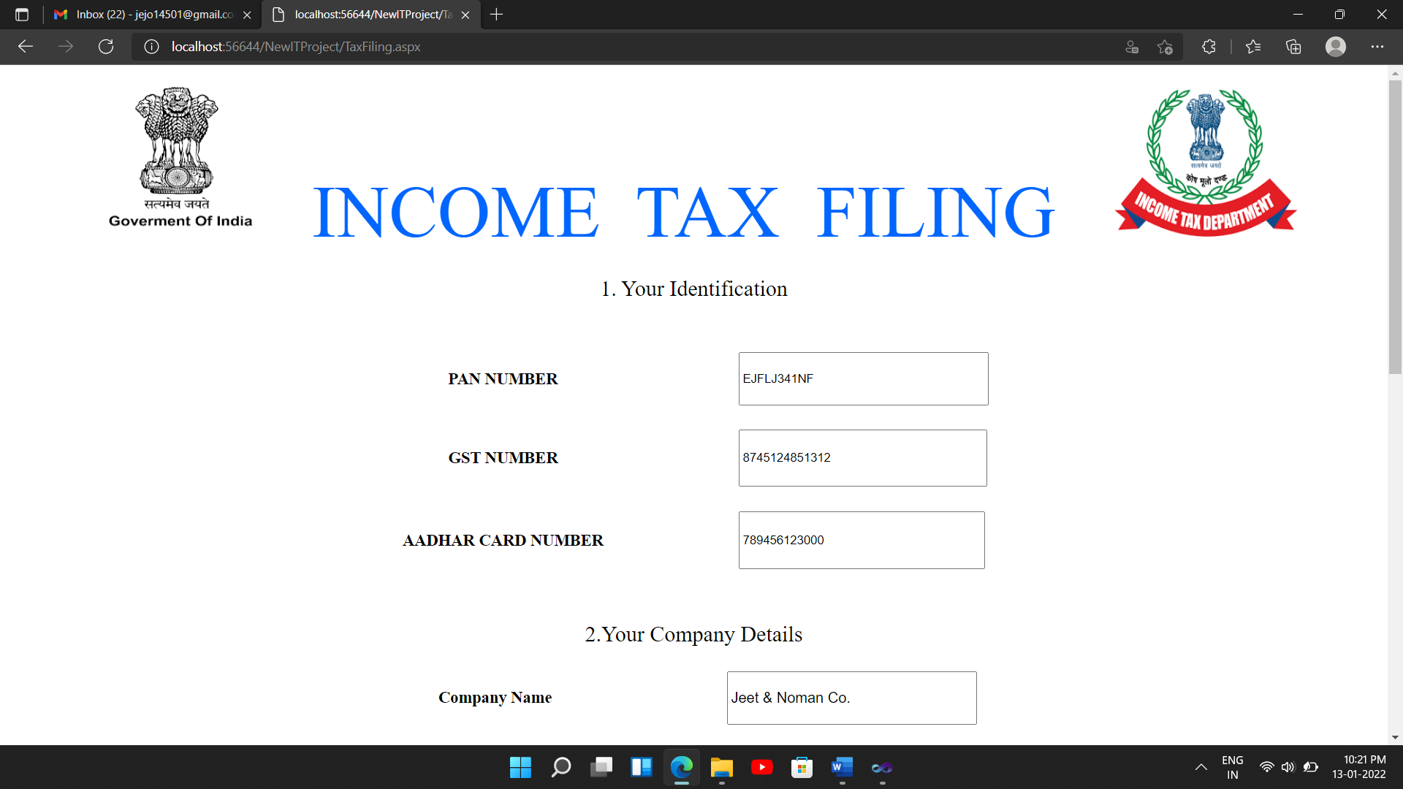

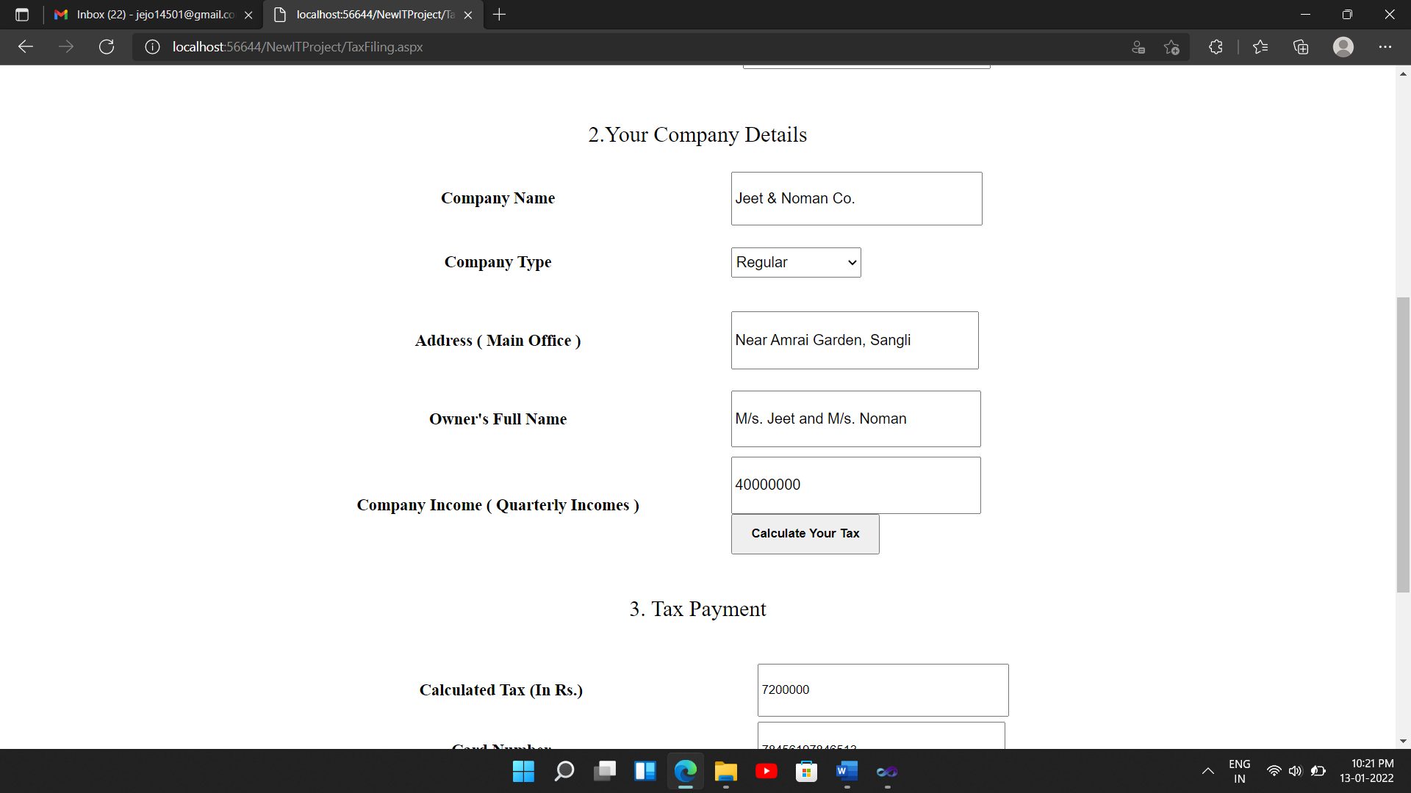

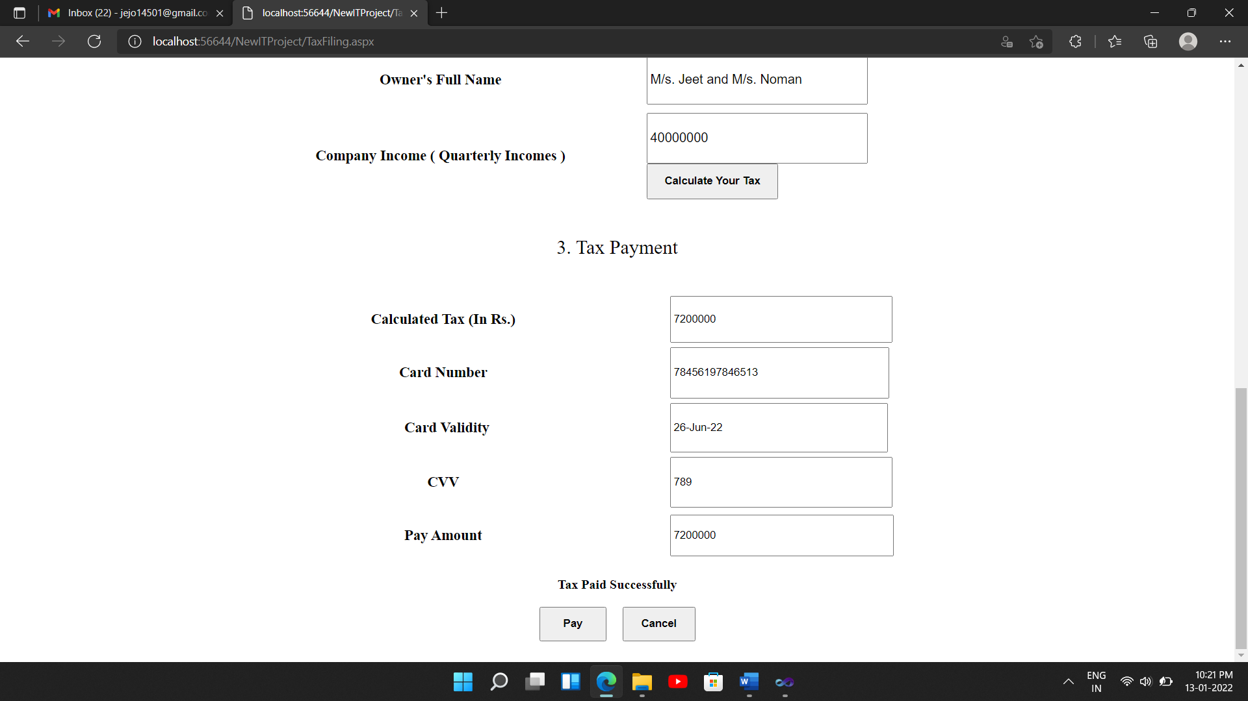

**4.3 Output design**

**a) Customer Details Page**

**Name:** Customer Details

**Description:** This page enables admin to view every customer’s data through this page.

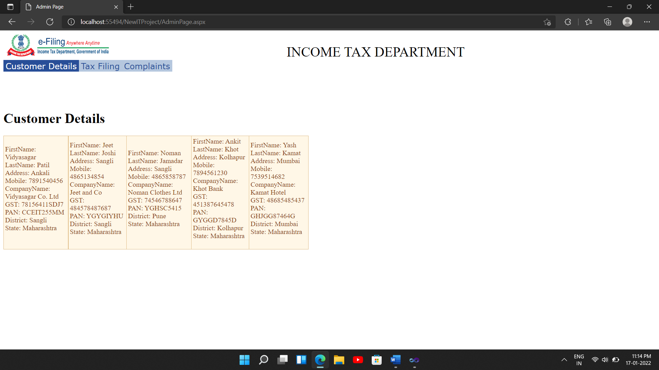

**b) Tax filing Page**

**Name:** Tax filing

**Description:** This page enables admin to view every tax payer’s data through this page.

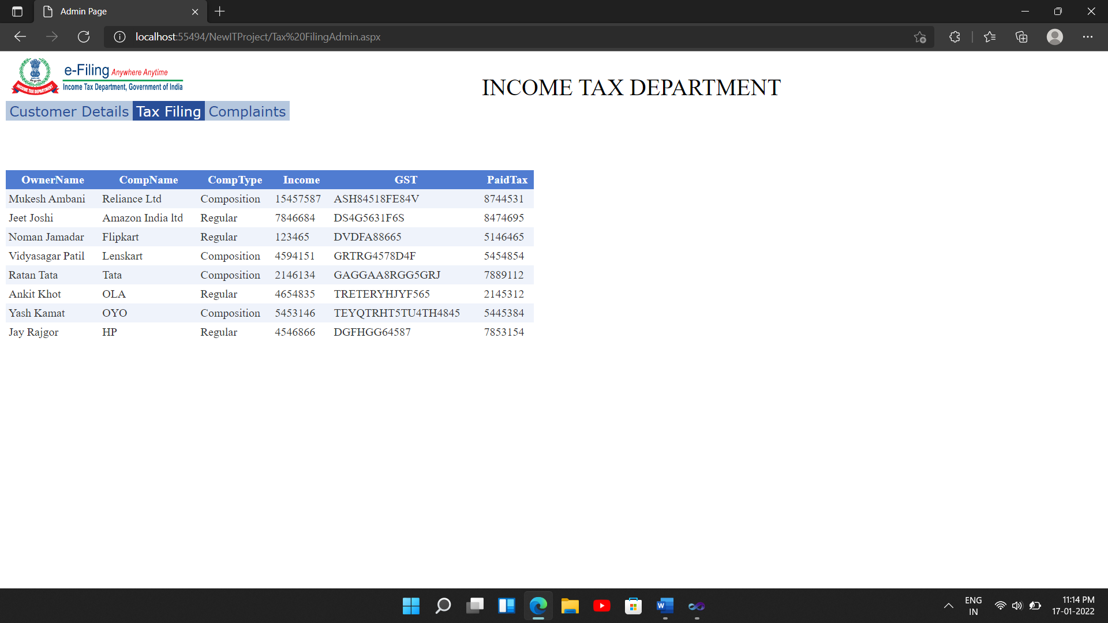

**c) Customer Complaints Page**

**Name:** Complaint Page

**Description:** This page enables admin to view every customer’s complaint through this page.

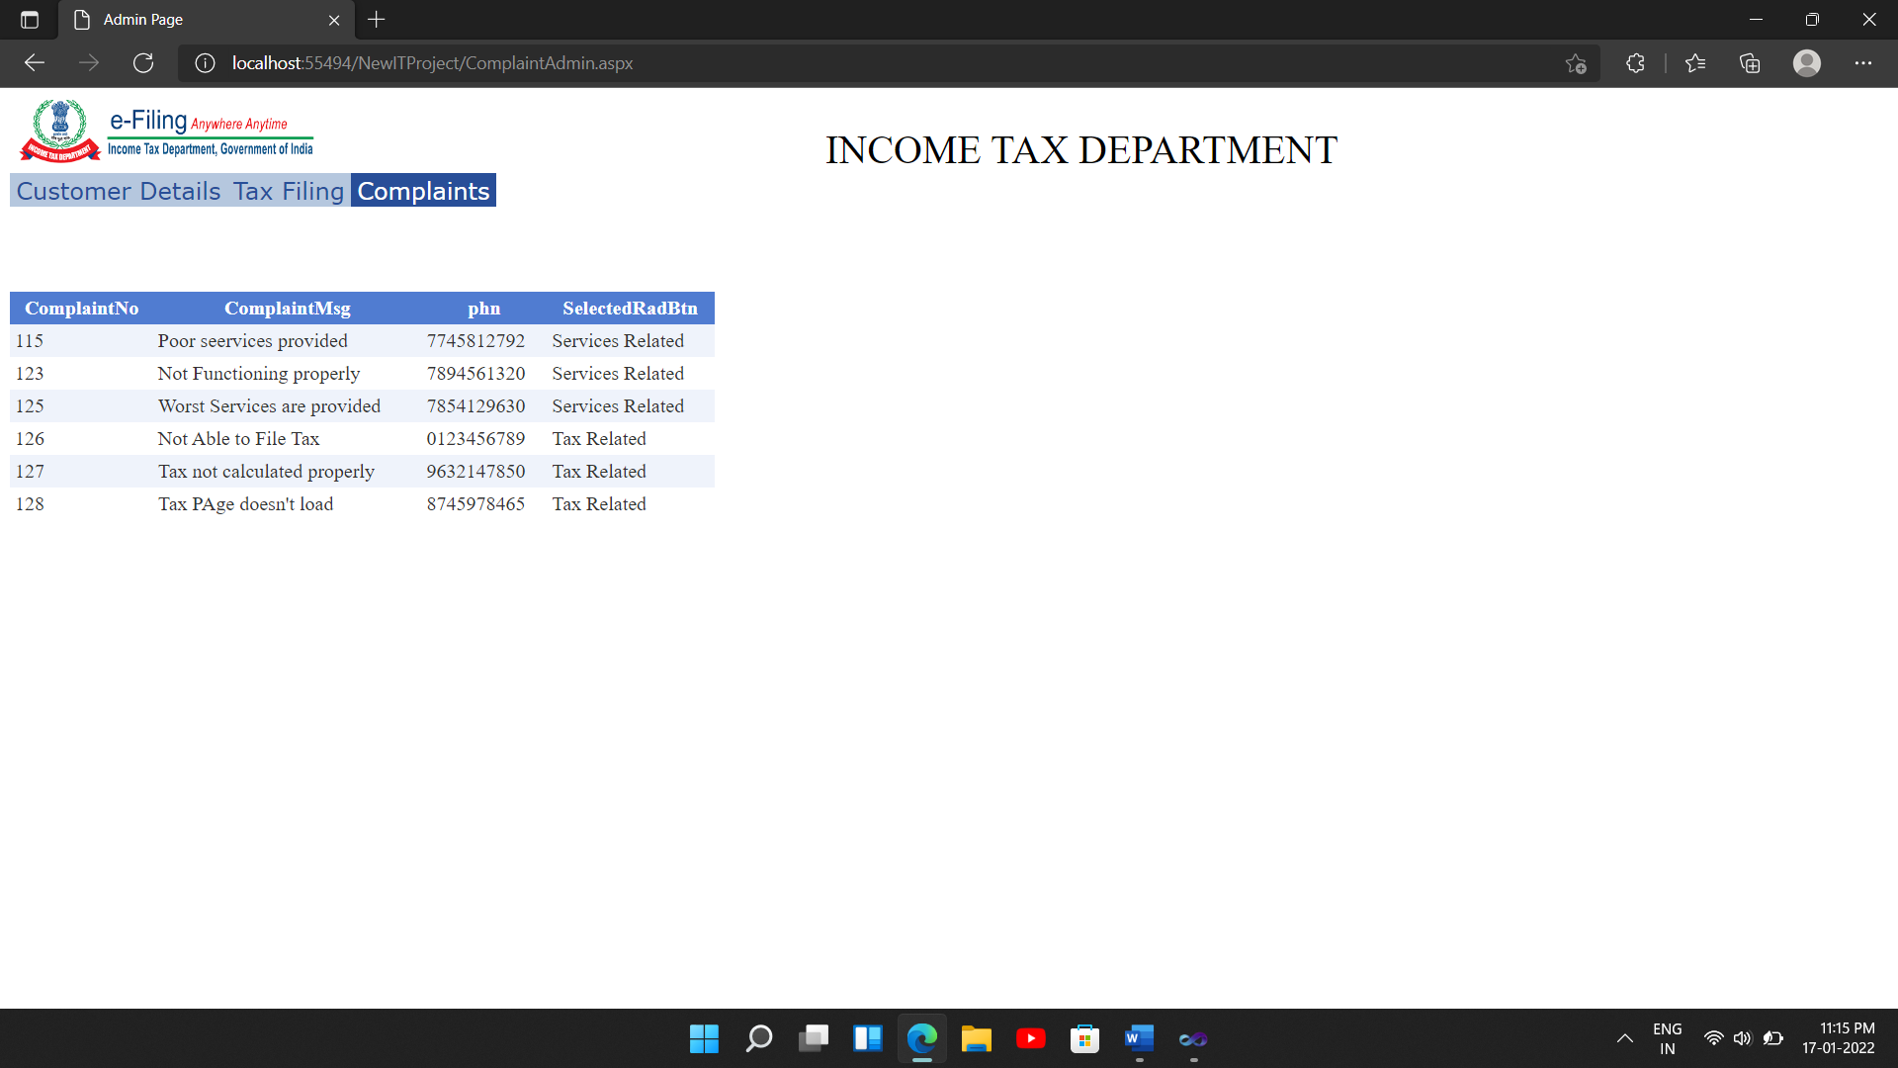

**5] Implementation**

**5.1 System Requirement**

**5.1.1 Hardware**

* 8GB Ram and above
* 2TB Hard Disk and above.
* Processor-P IV and above
* Keyboard-Touch screen pad.
* Monitor
* Mouse
* CPU-2GH2 &above
* Printer

**5.1.2 Software**

* Operating System: Windows XP or Vista or Windows-7
* Microsoft Visual Studio 2010
* Browser:IE-7 or any web browser(Internet Explorer, Mozilla Firefox, Google, Chrome)
* Adobe Flash Player

**5.2 User Guidelines**

**Home:**

* In This Page You got overall information about our website and image slider.

**Registration:**

* In this page the new registration for user.

**Login:**

* If the admin login from this page he'll redirect towards admin home pages

**Feedback/Complaints:**

* In this page the user gives the feedback or complaint about the websites.

**Sitemap:**

* In this page you got the Sitemap that means which pages or which links available in project.

**6]Conclusion and Suggestions**

**6.1] Conclusion**

This website is designed, developed and maintain​ed by us. Though all efforts have been made to ensure the accuracy of the content on this website. In case of any ambiguity or doubts, users are advised to verify/check with the Department(s) and/or other source(s), and to obtain appropriate professional advice.

Under no circumstances this Department will be liable for any expenses, loss or damage including, without limitation, indirect or consequential loss or damage or any expense, loss or damage whatsoever arising from use, or loss of use, of data arising out of or in connection with the use of this website.

The design and development of system will greatly enhance the information system. The website is economically and technically as well as operationally feasible. For maintenance and upgradation there occurs cost of the system.

This website is user friendly and it can be handled easily by the user. This website is designed in such a manner that it doesn’t disturb the workflow of the system, if any system changes are suggested.​​​

**6.2] Limitations**

* Traditional offices which do not have sufficient infrastructure find difficulties in uploading documents.
* Only administrator can access the database and make changes to it accordingly.
* Images and information are collected from the official website and other reference websites
* Online money transaction is not compatible with this website
* No availability of filing different types of taxes.
* No e-verification process can be done through this website.

**6.3] Suggestion**

* Live chat based chatbot for the users’ ease to solve their problems. i.e. Queries about Income Tax Filing procedures.
* Updated News for press releases should be flashed across all the platforms.
* Creating awareness about taxing systems and its procedure.

1. **References**

**7.1 Books:**

Simplified Approach to Income Tax

Taxman’s Students’ Guide to Income Tax including GST

**7.2 Periodicals and Newspapers: -**

The Economics Times

Times of India

**Web: -**

[www.incometaxindia.gov.in](http://www.incometaxindia.gov.in)

[www.w3schools.com](http://www.w3schools.com)

**7.3 Source Code (Including Main Logic Source Code)**

**A] Site Master**

<%@ Master Language="C#" AutoEventWireup="true" CodeFile="Site.master.cs" Inherits="SiteMaster" %>

<!DOCTYPE html PUBLIC "-//W3C//DTD XHTML 1.0 Strict//EN" "http://www.w3.org/TR/xhtml1/DTD/xhtml1-strict.dtd">

<html xmlns="http://www.w3.org/1999/xhtml" xml:lang="en">

<meta name="viewport" content="width=device-width, initial-scale=1.0">

<head runat="server">

<title></title>

<link href="~/Styles/Site.css" rel="stylesheet" type="text/css" />

<asp:ContentPlaceHolder ID="HeadContent" runat="server">

</asp:ContentPlaceHolder>

<style type="text/css">

.style1

{

height: 90px;

width: 124px;

padding-top:10px;

margin-top: 0px;

}

.style2

{

font-family: "Times New Roman", Times, serif;

}

.style3

{

font-family: "Times New Roman", Times, serif;

font-size: xx-large;

}

.menu

{

font-size: medium;

}

.style21

{

font-family: "Times New Roman", Times, serif;

color: #0066FF;

font-size: Larger;

}

.menu

{

text-align: left;

}

.menu

{

text-align: right;

}

.menu

{

font-size: large;

}

</style>

</head>

<body>

<form runat="server" style="width: 1451px; height: 2577px">

<div class="page" align="center">

<div class="header">

<div class="loginDisplay" align="center">

<div class="title">

<h1 style="font-family: 'Bookman Old Style'; font-size: x-large; font-weight: 400; font-style: normal; text-transform: capitalize; font-variant: normal; color: #3366FF; height: 125px; width: 1008px; background-color: #FFFFFF;"

class="style2">

<img class="style1" src="Photos/ITD%20logo.png" />&nbsp;&nbsp;&nbsp;&nbsp; <span class="style3">&nbsp;</span><strong style="font-size: xx-large"><span

class="style21">Income Tax Department</span></strong>&nbsp;&nbsp;&nbsp;

<img

class="style1" src="Photos/ITD%20logo.png"

style="top: auto; height: 90px; width: 126px;" /></h1>

</div>

<asp:Image ID="ImageDP" runat="server" Height="72px" Width="71px"

style="border-radius:50px" />

<br />

<asp:Label ID="Label1" runat="server" ForeColor="Black" Font-Bold="True"></asp:Label>

<asp:Label ID="Label2" runat="server" Font-Bold="True" ForeColor="Black"></asp:Label>

<br />

<asp:ImageButton ID="ImageButton1" runat="server" BorderStyle="None"

Height="43px" ImageUrl="Photos/logout.png" onclick="ImageButton1_Click"

Width="42px" />

</div>

<div class="clear hideSkiplink" dir="ltr">

<asp:Menu ID="NavigationMenu" runat="server" CssClass="menu"

EnableViewState="False" IncludeStyleBlock="False" Orientation="Horizontal"

BackColor="#B5C7DE" DynamicHorizontalOffset="2" Font-Names="Tahoma"

Font-Size="Medium" ForeColor="#CC0000" StaticSubMenuIndent="7px">

<DynamicHoverStyle BackColor="#42C1FF" ForeColor="Black" />

<DynamicMenuItemStyle HorizontalPadding="5px" VerticalPadding="2px"

BorderStyle="Solid" />

<DynamicMenuStyle BackColor="#B5C7DE" />

<DynamicSelectedStyle BackColor="#507CD1" />

<Items>

<asp:MenuItem NavigateUrl="~/Default.aspx" Text="Home"/>

<asp:MenuItem Text="Grievance Redressal" Value="Grievance Redressal"

NavigateUrl="~/Grievance.aspx">

<asp:MenuItem Text="Grievance Register" Value="Grievance Redressal"

NavigateUrl="~/ComplaintRegister.aspx">

</asp:MenuItem>

<asp:MenuItem NavigateUrl="~/ComplaintPage.aspx" Text="Complaint"

Value="Complaint"></asp:MenuItem>

<asp:MenuItem Text="Service Quality Policy" Value="Quality Policy"

NavigateUrl="~/ServiceQualityPolicy.aspx"></asp:MenuItem>

<asp:MenuItem Text="Contact Ask Centres" Value="Contact Ask Centres"

NavigateUrl="~/ContactAskCentre.aspx">

</asp:MenuItem>

</asp:MenuItem>

<asp:MenuItem Text="Forms Download" Value="Forms Download">

<asp:MenuItem Text="Income Tax Returns" Value="Income Tax Returns">

</asp:MenuItem>

<asp:MenuItem Text="Wealth Tax Returns" Value="Wealth Tax Returns">

</asp:MenuItem>

<asp:MenuItem Text="Challans" Value="Challans"></asp:MenuItem>

<asp:MenuItem Text="Tax Payer's Chart" Value="Other Forms"

NavigateUrl="~/TaxPayersChart.aspx"></asp:MenuItem>

</asp:MenuItem>

<asp:MenuItem Text="Contact Us" Value="Contact Us"></asp:MenuItem>

<asp:MenuItem Text="Feedback" Value="Feedback"></asp:MenuItem>

<asp:MenuItem Text="Tax Filing" Value="Publicity Campaign"

NavigateUrl="~/UserDetails.aspx">

</asp:MenuItem>

<asp:MenuItem NavigateUrl="~/About.aspx" Text="About Us" Value="About">

<asp:MenuItem Text="History Of Direct Taxation"

Value="History Of Direct Taxation"

NavigateUrl="~/HistoryOfDirectTaxation.aspx"></asp:MenuItem>

<asp:MenuItem Text="Organization And Functions"

Value="Organization And Functions"></asp:MenuItem>

<asp:MenuItem NavigateUrl="~/Payscale.aspx" Text="Designation And Payscale"

Value="Designation And Payscale"></asp:MenuItem>

</asp:MenuItem>

</Items>

<StaticHoverStyle BackColor="#284E98" ForeColor="White" />

<StaticMenuItemStyle HorizontalPadding="5px" VerticalPadding="2px" />

<StaticSelectedStyle BackColor="#507CD1" />

</asp:Menu>

&nbsp;</div>

</div>

<div class="main">

<asp:ContentPlaceHolder ID="MainContent" runat="server">

</asp:ContentPlaceHolder>

</div>

</div>

<div class="footer"

style="background-color: #666666; color: #FFFFFF; font-family: 'Arial Rounded MT Bold'; display: inline; text-align:center">

</div>

</form>

</body>

</html>

**B] Admin Site Master**

<%@ Master Language="C#" AutoEventWireup="true" CodeFile="AdminPage.master.cs" Inherits="AdminPage" %>

<!DOCTYPE html PUBLIC "-//W3C//DTD XHTML 1.0 Transitional//EN" "http://www.w3.org/TR/xhtml1/DTD/xhtml1-transitional.dtd">

<html xmlns="http://www.w3.org/1999/xhtml">

<head runat="server">

<title>Admin Page</title>

<asp:ContentPlaceHolder id="head" runat="server">

</asp:ContentPlaceHolder>

<style type="text/css">

.style2

{

width: 252px;

height: 53px;

}

.style3

{

font-size: xx-large;

}

.style4

{

text-align: left;

height: 157px;

}

.menu

{

font-size: large;

}

.menu

{

font-size: medium;

}

.menu

{

font-size: large;

}

.menu

{

font-size: large;

}

.menu

{

font-size: medium;

}

.menu

{

font-size: 0em;

}

.menu

{

font-size: x-large;

}

.menu

{

text-align: right;

}

.menu

{

text-align: left;

}

.menu

{

text-align: left;

}

.menu

{

font-size: medium;

}

</style>

</head>

<body>

<form id="form1" runat="server">

<div class="style4">

<img alt="ITD LOGO" class="style2" src="Photos/home%20logo.png" /><span

class="style3">&nbsp;&nbsp;&nbsp;&nbsp;&nbsp;&nbsp;&nbsp;&nbsp;&nbsp;&nbsp;&nbsp;&nbsp;&nbsp;&nbsp;&nbsp;&nbsp;&nbsp;&nbsp;&nbsp;&nbsp;&nbsp;&nbsp;&nbsp;&nbsp;&nbsp;&nbsp;&nbsp;&nbsp;&nbsp;&nbsp;&nbsp;&nbsp;&nbsp;&nbsp;&nbsp;&nbsp;&nbsp;&nbsp;&nbsp;&nbsp;&nbsp;&nbsp;&nbsp;&nbsp;&nbsp;&nbsp;&nbsp;&nbsp;&nbsp;&nbsp; INCOME TAX DEPARTMENT</span>

<br />

<asp:Menu ID="Menu1" runat="server" BackColor="#B5C7DE"

DynamicHorizontalOffset="2" Font-Names="Verdana" Font-Size="0.8em"

ForeColor="#284E98" StaticSubMenuIndent="10px" Orientation="Horizontal"

style="font-size: x-large; font-family: Webdings; text-align: center">

<DynamicHoverStyle BackColor="#284E98" ForeColor="White" />

<DynamicMenuItemStyle HorizontalPadding="5px" VerticalPadding="2px"

BorderStyle="Solid" BorderWidth="1px" />

<DynamicMenuStyle BackColor="#B5C7DE" BorderStyle="Solid" BorderWidth="1px" />

<DynamicSelectedStyle BackColor="#507CD1" />

<Items>

<asp:MenuItem Text="Customer Details" Value="Customer Details"

NavigateUrl="~/AdminPage.aspx"></asp:MenuItem>

<asp:MenuItem Text="Tax Filing" Value="Tax Filing"

NavigateUrl="~/Tax FilingAdmin.aspx"></asp:MenuItem>

<asp:MenuItem Text="Complaints" Value="Complaints"

NavigateUrl="~/ComplaintAdmin.aspx"></asp:MenuItem>

</Items>

<StaticHoverStyle BackColor="#284E98" ForeColor="White" />

<StaticMenuItemStyle HorizontalPadding="5px" VerticalPadding="2px" />

<StaticSelectedStyle BackColor="#507CD1" />

</asp:Menu>

</div>

<asp:ContentPlaceHolder id="ContentPlaceHolder1" runat="server">

</asp:ContentPlaceHolder>

</form>

</body>

</html>

**C] Login Page**

<%@ Page Language="C#" AutoEventWireup="true" CodeFile="Login.aspx.cs" Inherits="Login" %>

<!DOCTYPE html PUBLIC "-//W3C//DTD XHTML 1.0 Transitional//EN" "http://www.w3.org/TR/xhtml1/DTD/xhtml1-transitional.dtd">

<html xmlns="http://www.w3.org/1999/xhtml">

<meta name="viewport" content="width=device-width, initial-scale=1.0">

<head runat="server">

<title>Login</title>

<script type="text/javascript" src="https://unpkg.com/sweetalert/dist/sweetalert.min.js"></script>

<style type="text/css">

.Loginbtn

{

text-align: center;

border-radius:50px;

margin-right: 0px;

color:Blue;

background-color:White;

cursor: pointer;

font-weight:bolder;

font-family:"Times New Roman", Times, serif;

font-size: large;

}

.Loginbtn:hover

{

color: white;

background-color: #6699FF;

border-color:transparent;

}

.style8

{

width: 138px;

height: 102px;

margin-left: 23px;

margin-top: 13px;

margin-bottom: 0px;

}

.style2

{

border-color:Black;

}

.style11

{

height: 182px;

text-align: center;

}

.style19

{

text-align: center;

width: 329px;

font-family: "Times New Roman", Times, serif;

font-weight: bold;

height: 152px;

}

.style20

{

width: 335px;

text-align: center;

height: 152px;

}

.style21

{

font-family: "Times New Roman", Times, serif;

color: #3366FF;

font-size: Larger;

}

#form1

{

height: 778px;

width: 1514px;

}

.style26

{

text-align: center;

width: 329px;

font-family: "Times New Roman", Times, serif;

font-weight: bold;

height: 132px;

}

.style37

{

width: 335px;

text-align: center;

height: 132px;

}

.style41

{

text-align: center;

width: 650px;

}

.style42

{

font-style: normal;

}

</style>

</head>

<body style="width: 1512px; height: 779px; margin-right: 0px;">

<form id="form1" runat="server">

<div style="height: 759px; width: 1515px; margin-right: 0px;">

<div class="style11"

style="background-color: #5398FF; color: #000000; margin-bottom: 22px; width: 1516px;">

<strong style="font-size: xx-large">

<img alt="Logo" class="style8" src="Photos/ITD%20logo.png" style="border-radius:10px;"/><br />

<span class="style21" style="color: #000000">Income Tax Department</span></strong><br />

</div>

<table class="style2" align="center" frame="border" style="border-color: #000000; height: 438px; width: 655px;">

<tr>

<td class="style19"

style="font-style: italic; font-size: x-large; color: #333333">

Username (Email)</td>

<td class="style20">

<asp:TextBox ID="TextboxUser" runat="server" Width="190px" Height="35px" style="border-top:5px solid black; border-left: 0px none white; border-right:0px none white; border-top: 0px none white;"></asp:TextBox>

&nbsp;<asp:RequiredFieldValidator ID="RequiredFieldValidator1" runat="server"

ErrorMessage="Enter Username" ForeColor="Red" style="text-align: left"

ControlToValidate="TextboxUser"></asp:RequiredFieldValidator>

</td>

</tr>

<tr>

<td class="style26"

style="font-style: italic; font-size: x-large; color: #333333">

Password</td>

<td class="style37">

<asp:TextBox ID="TextBoxPwd" runat="server" Width="190px" TextMode="Password"

Height="35px" style="border-top:5px solid black; border-left: 0px none white; border-right:0px none white; border-top: 0px none white;"></asp:TextBox>

&nbsp;<asp:RequiredFieldValidator ID="RequiredFieldValidator2" runat="server"

ErrorMessage="Enter Password" ForeColor="Red"

ControlToValidate="TextBoxPwd"></asp:RequiredFieldValidator>

</td>

</tr>

<tr>

<td class="style26"

style="font-style: italic; font-size: x-large; color: #333333" colspan="2">

<p class="style41" style="font-size: large; height: 127px;">

<asp:Button ID="Button1" runat="server" Text="Login"

onclick="Button1_Click" Height="41px" Width="125px"

CssClass="Loginbtn"/>

&nbsp;&nbsp;&nbsp;&nbsp;&nbsp;

<asp:Button ID="Button2" runat="server" Text="Clear"

onclick="Button2_Click"

CssClass="Loginbtn" Height="41px" Width="125px"/>

<br/><br/><span class="style42"><asp:Label ID="Label2" runat="server" Font-Bold="True" ForeColor="Red"></asp:Label>

<br />

<asp:Label ID="Label1" runat="server" Text="New to this website ? "></asp:Label>

<asp:HyperLink ID="HyperLink2" runat="server" Font-Underline="False"

ForeColor="#3399FF" NavigateUrl="~/SignUp.aspx">SignUp Here</asp:HyperLink>

</span>

</p>

</td>

</tr>

</table>

<br />

</div>

</form>

</body>

</html>

**D] Sign up Page**

<%@ Page Language="C#" AutoEventWireup="true" CodeFile="SignUp.aspx.cs" Inherits="SignUp" %>

<!DOCTYPE html PUBLIC "-//W3C//DTD XHTML 1.0 Transitional//EN" "http://www.w3.org/TR/xhtml1/DTD/xhtml1-transitional.dtd">

<html xmlns="http://www.w3.org/1999/xhtml">

<meta name="viewport" content="width=device-width, initial-scale=1.0">

<head runat="server">

<title>ITD SignUp</title>

<style type="text/css">

.Loginbtn

{

text-align: center;

border-radius:50px;

margin-right: 0px;

color:Blue;

background-color:White;

cursor: pointer;

font-weight:bolder;

font-family:"Times New Roman", Times, serif;

font-size: large;

}

.Loginbtn:hover

{

color: white;

background-color: #6699FF;

border-color:transparent;

}

.style21

{

text-align: center;

width: 1497px;

margin-top: 12px;

}

.style27

{

font-size: x-large;

}

.style51

{

width: 282px;

font-family: "Times New Roman", Times, serif;

font-weight: bold;

text-align: center;

font-size: x-large;

height: 111px;

}

.style52

{

width: 400px;

text-align: center;

height: 111px;

}

#form1

{

height: 889px;

width: 1509px;

}

.style11

{

height: 164px;

text-align: center;

}

.style8

{

width: 138px;

height: 102px;

margin-left: 23px;

margin-top: 13px;

margin-bottom: 0px;

}

.style60

{

width: 81%;

border: 1px solid #000000;

}

.style62

{

font-size: x-large;

height: 218px;

text-align: center;

width: 244px;

}

.style63

{

height: 111px;

text-align: center;

}

.style64

{

text-align: center;

width: 244px;

font-family: "Times New Roman", Times, serif;

font-weight: bold;

font-size: x-large;

height: 111px;

}

.style66

{

width: 282px;

font-size: x-large;

height: 218px;

}

.style67

{

height: 218px;

text-align: center;

}

.style68

{

text-align: center;

height: 102px;

}

.style69

{

width: 244px;

font-family: "Times New Roman", Times, serif;

font-weight: bold;

text-align: center;

font-size: x-large;

height: 102px;

}

.style70

{

width: 282px;

font-family: "Times New Roman", Times, serif;

font-weight: bold;

text-align: center;

font-size: x-large;

height: 102px;

}

</style>

</head>

<body style="height: 890px; width: 1505px">

<form id="form1" runat="server">

<div style="width: 1502px; height: 773px;">

<div>

<div class="style11"

style="background-color: #5398FF; color: #000000; margin-bottom: 3px; width: 1502px; margin-top: 0px;">

<strong style="font-size: xx-large">

<img alt="Logo" class="style8" src="Photos/ITD%20logo.png" style="border-radius:10px;"/><br />

<span class="style21" style="color: #000000">Income Tax Department</span></strong><br />

</div>

<br />

<table align="center" cellspacing="1" class="style60"

style="border-color: #000000; border-width: 2px; height: 441px;">

<tr>

<td class="style69">

First Name</td>

<td class="style68">

<asp:TextBox ID="TextBoxFN" runat="server" Height="42px" Width="209px" style="border-top:5px solid black; border-left: 0px none; border-right:0px none; border-top: 0px none;"></asp:TextBox>

<br />

<asp:RequiredFieldValidator ID="RequiredFieldValidator3" runat="server"

ErrorMessage="First Name Required" ControlToValidate="TextBoxFN"

Font-Bold="False" ForeColor="Red"></asp:RequiredFieldValidator>

</td>

<td class="style70">

Last Name</td>

<td class="style68">

<asp:TextBox ID="TextBoxLN" runat="server" Height="42px" Width="209px" style="border-top:5px solid black; border-left: 0px none; border-right:0px none; border-top: 0px none;"></asp:TextBox>

<br />

<asp:RequiredFieldValidator ID="RequiredFieldValidator4" runat="server"

ErrorMessage="Last Name Required" ControlToValidate="TextBoxLN"

Font-Bold="False" ForeColor="Red"></asp:RequiredFieldValidator>

</td>

</tr>

<tr>

<td class="style62">

<strong>Upload Photo</strong></td>

<td class="style67">

<asp:Image ID="ImageDP" runat="server" Height="106px" style="text-align: left"

Width="119px" BorderStyle="Solid" BorderWidth="1px" />

&nbsp;<br />

<asp:Label ID="Label3" runat="server" Font-Bold="False" ForeColor="Red"

Visible="False"></asp:Label>

<br />

<asp:Button ID="Button3" runat="server" onclick="Button3_Click"

Text="Upload Image" Height="32px" Width="131px" />

<br />

<asp:FileUpload ID="FileUpload1" runat="server" style="border-top:5px solid black; border-left: 0px none; border-right:0px none; border-top: 0px none;"/>

</td>

<td class="style66">

<strong>&nbsp;&nbsp; Email (Username)</strong></td>

<td class="style67">

<asp:TextBox ID="TextboxUser" runat="server" Width="211px" Height="43px" style="border-top:5px solid black; border-left: 0px none; border-right:0px none; border-top: 0px none;"></asp:TextBox>

<br />

<asp:RequiredFieldValidator ID="RequiredFieldValidator1" runat="server"

ErrorMessage="Enter email" ForeColor="Red" ControlToValidate="TextboxUser"></asp:RequiredFieldValidator>

</td>

</tr>

<tr>

<td class="style64">

Password</td>

<td class="style63">

<asp:TextBox ID="TextBoxPwd" runat="server" Width="210px" TextMode="Password"

Height="42px" style="border-top:5px solid black; border-left: 0px none; border-right:0px none; border-top: 0px none;"></asp:TextBox>

<br />

<asp:RequiredFieldValidator ID="RequiredFieldValidator2" runat="server"

ErrorMessage="Enter Password" ForeColor="Red"

ControlToValidate="TextBoxPwd"></asp:RequiredFieldValidator>

</td>

<td class="style51">

Confirm Password</td>

<td class="style52">

<asp:TextBox ID="TextBoxCNFRM" runat="server" TextMode="Password" Height="35px"

Width="209px" style="border-top:5px solid black; border-left: 0px none; border-right:0px none; border-top: 0px none;"></asp:TextBox>

<br />

<asp:CompareValidator ID="CompareValidator1" runat="server"

ErrorMessage="Password Mismatch" ForeColor="Red"

ControlToCompare="TextBoxPwd" ControlToValidate="TextBoxCNFRM"></asp:CompareValidator>

<br />

<asp:RequiredFieldValidator ID="RequiredFieldValidator5" runat="server"

ControlToValidate="TextBoxCNFRM" ErrorMessage="Enter Confirmed Password"

ForeColor="Red"></asp:RequiredFieldValidator>

</td>

</tr>

</table>

</div>

<p class="style21">

<asp:Button ID="SignUpBtn" runat="server" Text="SignUp" CssClass="Loginbtn"

Height="41px" Width="109px" onclick="SignUpBtn_Click1" />

&nbsp;&nbsp;&nbsp;

<asp:Button ID="Button2" runat="server" Text="Clear" Height="41px" Width="109px"

CssClass="Loginbtn" onclick="Button2_Click1" />

<br />

<asp:Label ID="Label2" runat="server" ForeColor="#3399FF" Font-Bold="True" Height="31px"

style="font-size: large" Width="130px"></asp:Label>

<br />

<asp:Label ID="Label1" runat="server" Text="Already Registered ? "

CssClass="style27"></asp:Label>

<asp:HyperLink ID="HyperLink1" runat="server" Font-Underline="False"

ForeColor="#3399FF" NavigateUrl="~/Login.aspx" CssClass="style27">Login here.</asp:HyperLink>

</p>

</div>

</form>

</body>

</html>

**E] Default Page**

<%@ Page Title="Home Page" Language="C#" MasterPageFile="~/Site.master" AutoEventWireup="true"

CodeFile="Default.aspx.cs" Inherits="_Default" %>

<asp:Content ID="HeaderContent" runat="server" ContentPlaceHolderID="HeadContent">

<style type="text/css">

.style2

{

text-align: center;

}

.style22

{

font-size: x-large;

}

.style24

{

text-decoration: none;

}

.style25

{

font-size: large;

}

.style26

{

color: #0066FF;

}

.style27

{

font-size: large;

color: #0066FF;

}

</style>

</asp:Content>

<asp:Content ID="BodyContent" runat="server" ContentPlaceHolderID="MainContent">

<asp:UpdatePanel ID="UpdatePanel1" runat="server">

<ContentTemplate>

<asp:AdRotator ID="AdRotator1" runat="server" BorderColor="White"

BorderStyle="Solid" BorderWidth="2px" DataSourceID="XmlSlider" Height="325px"

style="text-align: center; float:left; margin-top: 13px;" Width="955px" />

<asp:XmlDataSource ID="XmlSlider" runat="server"

DataFile="~/SliderImageXML.xml"></asp:XmlDataSource>

<asp:ScriptManager ID="ScriptManager1" runat="server">

</asp:ScriptManager>

<asp:Timer ID="Timer1" runat="server" Interval="1500">

</asp:Timer>

<div style="float: right; height: 389px; width: 307px; margin-top: 0px;">

<ul style="height: 380px; width: 293px; border-style: solid; border-width: 1px; margin-left: 0px; margin-right: 16px;">

<li class="style22"

style=" list-style-type: none; height: 60px; width: 275px;"><b>

<em>Your Help Center</em></b></li>

<li class="style25" style="list-style-type: none; width: 263px; height: 72px;"border-style:

solid; border-width: 1px; width: 269px; height: 88px;">

<a class="style24" href="DosAndDonts.aspx"

style="height: 70px; width: 275px; list-style-type: none;">

<span class="style28"><span class="style25">Do&#39;s And Dont&#39;s</span>

<li class="style25" style="list-style-type: none; width: 269px; height: 74px;">

<a class="style24" href="Brochure.aspx"

style="height: 70px; width: 275px; list-style-type: none;">

<span class="style28"><span class="style27">Brochure</span>

<li class="style25" style="list-style-type: none; width: 269px; height: 75px;">

<a class="style24" href="Abbreviations.aspx"

style="height: 70px; width: 275px; list-style-type: none;">

<span class="style26">Abbreviations</span></li>

<li class="style25" style="list-style-type: none; width: 268px; height: 85px;">

<a class="style24" href="SAUA.aspx"

style="height: 70px; width: 275px; list-style-type: none;">

</span class="style26">Scanning and Uploading of Attachments</span></li>

</ul>

</div>

</a></b>

</ContentTemplate>

</asp:UpdatePanel>

</asp:Content>

**F] Tax Filing Page**

<%@ Page Title="" Language="C#" MasterPageFile="~/TaxFiling.master" AutoEventWireup="true" CodeFile="TaxFiling.aspx.cs" Inherits="Default2" %>

<asp:Content ID="Content1" ContentPlaceHolderID="head" Runat="Server">

<style type="text/css">

.style11

{

text-align: center;

width: 1546px;

height: 54px;

font-weight: bold;

font-size: large;

color: #000000;

}

.style12

{

width: 678px;

height: 54px;

font-size: medium;

}

.style16

{

text-align: center;

width: 1351px;

height: 51px;

color: #000000;

font-weight: bold;

font-size: large;

background-color: #FFFFFF;

}

.style17

{

font-size: medium;

}

.style19

{

text-align: center;

width: 1351px;

height: 60px;

color: #000000;

font-weight: bold;

font-size: large;

background-color: #FFFFFF;

}

.style20

{

width: 678px;

height: 60px;

font-size: medium;

}

.style21

{

text-align: center;

width: 1351px;

height: 58px;

color: #000000;

font-weight: bold;

font-size: large;

background-color: #FFFFFF;

}

.style22

{

width: 678px;

height: 58px;

font-size: medium;

}

.style5

{

font-family: "Times New Roman", Times, serif;

font-size: large;

width: 1546px;

text-align: center;

font-weight: bold;

color: #000000;

}

.style6

{

width: 553px;

font-size: medium;

text-align: left;

}

.style9

{

text-align: center;

width: 1546px;

height: 70px;

font-size: large;

color: #000000;

font-weight: bold;

}

.style10

{

width: 820px;

height: 70px;

font-size: medium;

text-align: left;

}

.style13

{

text-align: center;

width: 1546px;

height: 89px;

font-size: large;

color: #000000;

font-weight: bold;

}

.style14

{

width: 820px;

height: 89px;

font-size: medium;

text-align: left;

}

.style15

{

text-align: center;

width: 1546px;

height: 71px;

font-size: large;

color: #000000;

font-weight: bold;

}

.style23

{

text-align: center;

font-size: x-large;

}

.style24

{

text-align: left;

width: 776px;

height: 51px;

color: #000000;

font-weight: bold;

font-size: large;

background-color: #FFFFFF;

}

.style25

{

width: 819px;

height: 54px;

font-size: medium;

text-align: left;

}

.style26

{

text-align: left;

width: 776px;

height: 60px;

color: #000000;

font-weight: bold;

font-size: large;

background-color: #FFFFFF;

}

.style27

{

text-align: left;

width: 776px;

height: 54px;

font-weight: bold;

font-size: large;

color: #000000;

}

.style28

{

text-align: center;

width: 1351px;

height: 54px;

font-weight: bold;

font-size: large;

color: #000000;

}

.style29

{

width: 678px;

height: 51px;

font-size: medium;

}

.style30

{

font-family: "Times New Roman", Times, serif;

font-size: large;

width: 1617px;

text-align: center;

font-weight: bold;

color: #000000;

}

.style31

{

font-family: "Times New Roman", Times, serif;

font-size: large;

width: 1617px;

text-align: center;

font-weight: bold;

color: #000000;

height: 51px;

}

</style>

</asp:Content>

<asp:Content ID="Content2" ContentPlaceHolderID="ContentPlaceHolder1" Runat="Server">

<p class="style4" style="font-size: x-large">1. Your Identification</p><br />

<table cellpadding="2" class="style3" align="center"

style="height: 266px; width: 931px">

<tr>

<td class="style30">

PAN NUMBER</td>

<td class="style27">

<asp:TextBox ID="TBPAN" runat="server" Height="52px" Width="265px"

MaxLength="10"></asp:TextBox>

</td>

</tr>

<tr>

<td class="style31">

GST NUMBER</td>

<td class="style24" bgcolor="#3399FF"

style="border-collapse: collapse;">

<asp:TextBox ID="TBGST" runat="server" Height="56px" Width="264px"

MaxLength="15"></asp:TextBox>

</td>

</tr>

<tr>

<td class="style30">

AADHAR CARD NUMBER</td>

<td class="style26">

<asp:TextBox ID="TBAadNo" runat="server" Height="57px" Width="261px"

MaxLength="12"></asp:TextBox>

</td>

</tr>

</table>

<br />

<p class="style23">2.Your Company Details</p>

<table cellpadding="2" class="style3" align="center"

style="height: 373px; width: 940px">

<tr>

<td class="style11">

Company Name</td>

<td class="style25">

<asp:TextBox ID="TBCompNm" runat="server" Height="52px" Width="265px"

CssClass="style17"></asp:TextBox>

</td>

</tr>

<tr>

<td class="style9">

Company Type</td>

<td class="style10">

<asp:DropDownList ID="DDCompType" runat="server" Height="33px" Width="141px"

CssClass="style17">

<asp:ListItem>Regular</asp:ListItem>

<asp:ListItem>Composition</asp:ListItem>

</asp:DropDownList>

</td>

</tr>

<tr>

<td class="style13">

Address ( Main Office )</td>

<td class="style14">

<asp:TextBox ID="TBAdd" runat="server" Height="57px" Width="261px"

CssClass="style17"></asp:TextBox>

</td>

</tr>

<tr>

<td class="style15">

Owner&#39;s Full Name</td>

<td class="style24">

<asp:TextBox ID="TBOwnNm" runat="server" Height="56px" Width="264px"

CssClass="style17"></asp:TextBox>

</td>

</tr>

<tr>

<td class="style5">

Company Income ( Quarterly Incomes )</td>

<td class="style6">

<asp:TextBox ID="TBIncome" runat="server" Height="56px" Width="264px"

CssClass="style17"></asp:TextBox>

&nbsp;<asp:Button ID="Button1" runat="server" Height="44px" onclick="Button1_Click"

style="font-weight: 700" Text="Calculate Your Tax" Width="161px" />

</td>

</tr>

</table>

<asp:TextBox ID="TextBox1" runat="server" ForeColor="White" Visible="False">18</asp:TextBox>

<br />

<p class="style23">3. Tax Payment</p>

<br />

<table cellpadding="2" class="style3" align="center"

style="height: 245px; width: 984px;">

<tr>

<td class="style28">

Calculated Tax (In Rs.)</td>

<td class="style12">

<asp:TextBox ID="TBTax" runat="server" Height="52px" Width="265px"

ReadOnly="True"></asp:TextBox>

</td>

</tr>

<tr>

<td class="style16" bgcolor="#3399FF"

style="border-collapse: collapse;">

Card Number</td>

<td class="style29">

<asp:TextBox ID="TBCard" runat="server" Height="57px" Width="261px"></asp:TextBox>

</td>

</tr>

<tr>

<td class="style19">

&nbsp;&nbsp;Card Validity</td>

<td class="style20">

<asp:TextBox ID="TBValidity" runat="server" Height="55px" Width="260px"></asp:TextBox>

</td>

</tr>

<tr>

<td class="style21">

CVV</td>

<td class="style22">

<asp:TextBox ID="TBCVV" runat="server" Height="56px" Width="265px"></asp:TextBox>

</td>

</tr>

<tr>

<td class="style21">

Pay Amount</td>

<td class="style22">

<asp:TextBox ID="TBPay" runat="server" Height="45px" Width="267px"></asp:TextBox>

</td>

</tr>

</table>

<br />

<div>

<div class="style4">

<asp:Label ID="Label1" runat="server" ForeColor="Black"

style="font-size: medium; font-weight: 700"></asp:Label>

<br />

<br />

<asp:Button ID="PayBtn" runat="server" Text="Pay" Height="43px" Width="83px"

onclick="PayBtn_Click" style="font-weight: 700" />

&nbsp;&nbsp;&nbsp;

<asp:Button ID="Cancel" runat="server" Text="Cancel" Height="42px"

Width="89px" onclick="Cancel_Click" style="font-weight: 700" />

</div>

&nbsp;</div>

</asp:Content>

**G] Xml File**

<?xml version="1.0" encoding="utf-8" ?>

<Advertisements>

<Ad>

<ImageUrl>~\Photos\home logo.png</ImageUrl>

</Ad>

<Ad>

<ImageUrl>~\Photos\1.jpeg</ImageUrl>

</Ad>

<Ad>

<ImageUrl>~\Photos\2.jpeg</ImageUrl>

</Ad>

<Ad>

<ImageUrl>~\Photos\3.jpeg</ImageUrl>

</Ad>

<Ad>

<ImageUrl>~\Photos\4.jpg</ImageUrl>

</Ad>

<Ad>

<ImageUrl>~\Photos\5.jpeg</ImageUrl>

</Ad>

<Ad>

<ImageUrl>~\Photos\6.jpeg</ImageUrl>

</Ad>

</Advertisements>

**H] Complaint Register**

<%@ Page Title="" Language="C#" MasterPageFile="~/Site.master" AutoEventWireup="true" CodeFile="ComplaintRegister.aspx.cs" Inherits="ComplaintRegister" %>

<asp:Content ID="Content1" ContentPlaceHolderID="HeadContent" Runat="Server">

<style type="text/css">

}

.style22

{

font-size: large;

}

.style23

{

font-size: medium;

}

.style24

{

text-align: center;

}

</style>

</asp:Content>

<asp:Content ID="Content2" ContentPlaceHolderID="MainContent" Runat="Server">

<h1 style="font-family: 'Arial Unicode MS'; font-weight: bolder">Register your Grievances</h1>

<div style="font-family: 'Arial Unicode MS'; font-weight: bolder; height: 69px; width: 762px;">

<span class="style22">Select Your Choice<br />

</span><span class="style23">

<asp:RadioButton ID="Tax" runat="server" Text="TAX RELATED"

GroupName="CHOICE" />

&nbsp;<asp:RadioButton ID="Service" runat="server" Text="OUR SERVICE RELATED"

GroupName="CHOICE" />

&nbsp;<asp:RadioButton ID="OTHER" runat="server" GroupName="CHOICE"

Text="OTHER GRIEVANCES" />

</span>

</div>

<p class="style24"

style="font-family: 'Arial Unicode MS'; font-weight: bolder; width: 552px;">

<span class="style22">YOUR MOBILE NUMBER<br />

</span>

<asp:TextBox ID="TBPHN" runat="server" Height="44px"

Width="200px" MaxLength="10"></asp:TextBox>

<br />

<asp:RegularExpressionValidator ID="RegularExpressionValidator1" runat="server"

ControlToValidate="TBPHN" ErrorMessage="Enter Valid Number" ForeColor="Red"

ValidationExpression="[7-9][0-9]{9}"></asp:RegularExpressionValidator>

<br />

<span class="style22">YOUR GRIEVANCE HERE<br />

</span>

<asp:TextBox ID="TBMSG" runat="server" Height="83px" Width="268px"></asp:TextBox>

<br />

<asp:RequiredFieldValidator ID="RequiredFieldValidator1" runat="server"

ControlToValidate="TBMSG" ErrorMessage="Enter Your Grievance" ForeColor="Red"></asp:RequiredFieldValidator>

<br />

<asp:Button ID="Button1" runat="server"

Height="43px" Text="Submit" Width="109px"

onclick="Button1_Click" CssClass="submitButton" />

&nbsp;&nbsp;&nbsp;

<asp:Button ID="Button4" runat="server" Height="42px"

Text="Clear" Width="107px" onclick="Button4_Click"

CssClass="submitButton" />

</p>

<br /><asp:Label ID="LBMSG" runat="server"

style="font-weight: 700; font-size: large"></asp:Label>

</p>

</asp:Content>

**7.4] Site Map**